Geography Wider Listening Recommendation
Key Stage 3 and 4

The Geographical Association: Podcasts – listen to the experts - https://www.geography.org.uk/GeogPod-The-GAs-Podcast

Each episode, the host John Lyon talks to a guest from within the Geography community to discuss their work and areas of interest. You can select the podcasts that you want to explore this could be for interest, curiosity (all geographers are curious) or to extend your knowledge and understanding of the geography you are studying.
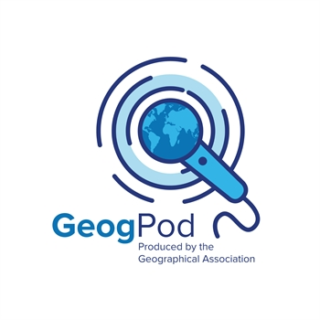
GeogPod is available on most main podcast apps, including Spotify and iTunes (we should be on Google Podcasts, Acast and Stitcher soon too!). Just search, 'GeogPod' to find them.

